Localization of Microsoft® Office© marketing web sites
Susan Kaltenbach
March 18, 2002
Abstract:
We reviewed 54 international Microsoft® Office© marketing web sites to identify cultural differences in their presentation. We then applied the cultural identifier metrics of Hofstede and Trompenaars to strongly localized web sites. An examination was done to see if the metrics were correct identifiers for the localization efforts we observed. In most cases, the metrics described by Hofstede and Trompenaars were not relevant to our discussion. This could be due to the amount of localization allowed each subsidiary by the Microsoft Corporation. It could also be due to the actual product and medium involved. We suggest that an examination of popular culture artifacts would be more relevant to internationalized technical writing than the metrics used in the past.

Introduction
This is a post-hoc case study of international Microsoft® Office© marketing web sites. The Office marketing web sites are intended to sell the Office product to the audience. The web site must reach the widest audience on the most basic, uncontroversial level in order to be mass-appealing. Since they are essentially advertising artifacts, these Office marketing web sites present a unique opportunity to study “what Microsoft thinks the local population thinks is appealing.”
There are a total of 54 MS Office web sites linked to the “Office Worldwide” web site (http://microsoft.com/office/worldwide.asp) at the U.S. Microsoft Office web site.
Microsoft maintains a corporate style guide to be followed for all (external) artifacts, including web sites. Thus, the font, color scheme, and format are dictated by corporate standards rather than local decisions. Due to this standardization, when there is a localized difference, it is quickly identifiable.
Interestingly, Microsoft produces its own photographs for inclusion in their artifacts. As a result, photographs and images used in artifacts all come from a common source. Thus, each international web site includes the same faces, colors and icons as any other international web site. Further, almost all of the photographs used take the form of a person in their workplace; almost none are of informal, relaxed people outside of work.
During this discussion, the phrase “home page” refers to the first, or top, web site the visitor encounters when visiting the site. All web sites visited can be described as “web sites,” including the home page.

Background
Information on how Microsoft performs localization was gathered from several sources, including anonymous Microsoft employees and available public information.
Localization of Microsoft products, including web sites, is mostly performed by the Microsoft localization team in Dublin, Ireland. It is in Ireland that the language and cultural localization efforts are performed by nationals of the targeted countries.
Most of the localization efforts are of a general nature, typified by Nancy Hoft as general localizations. These efforts include superficial cultural differences such as language, currency formats, date formats, technical phraseology, etc.
Lacking is the Radical localization that includes cultural differences in culture perceptions, actions, and thinking. In most cases, decisions made for cultural appropriateness are made on the part of the localizer and the product owner. Radical localization addresses the cultural identifiers in an audience. It appears that any efforts at radical localization are performed on the most miniscule level by localizers in the selection of photographs, advertisements, and simple layout changes.
A breakdown of the apparent standard corporate pattern for Office home page real estate is analyzed below:

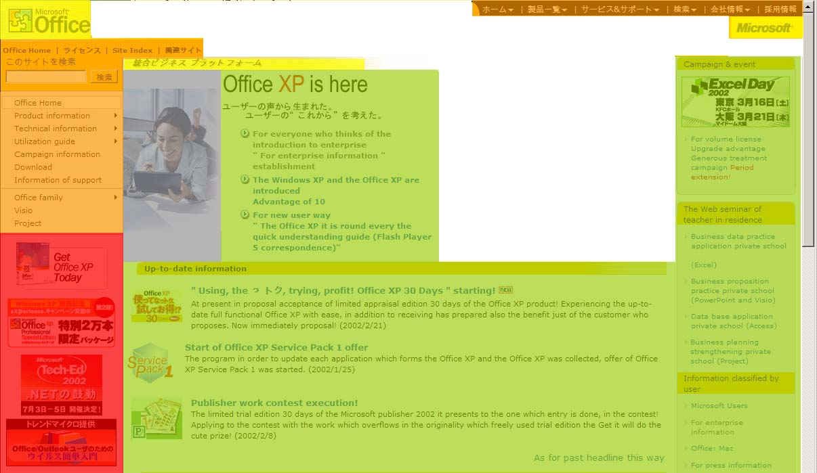
Figure 1: Japan Office home page with deconstruction
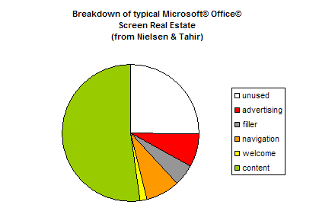

This issue is relevant to the business marketing schema of the Microsoft Corporation. By investigating the localization used in their Office marketing web sites, we are able to examine what attempts are made to address a local audience. The broader issue is the appropriate amount and type of localization for successful internationalized marketing.
When all localized differences have been collated and categorized, the main research question can be answered: Will the differences observed in the review of these internationalized web sites concur with our readings about cultural differences appearing in Technical Communications? Do the cultural identifiers as proposed Hofstede and Trompenaars actually translate into localized expressions in localized web sites? Or do the characteristics we observe actually map differently? By collating these data, we are able to test whether or not it is actually correct to apply these cultural associations.

Approach
In this study, we will be evaluating each web site based on schema collected from various writing of cultural identifiers. The theories of Geert Hofstede and Fons Trompenaars dominate many discussions of cross-cultural examinations. Each also provides a metric of cultural identifiers, and associates various nations based on the identifiers. A discussion of their theories is below.
Hofstede (1980) defines culture as "the collective programming of the mind which distinguishes the members of one human group from another" (p. 260). His work is possibly the most commonly referred to in the literature.
The five “Hofstede identifiers” can be described as follows:
- Individualism reflects the way members emphasize their own needs over the group's needs.
- Power Distance describes how subordinates respond to authority figures and their attitudes towards power relationships. A higher-distance power culture can have an unapproachable “top dog” with agents on increasingly lower-powered levels to affect changes. A low-distance power culture can have an approachable “top dog” that, at least superficially, can be approached by anyone in the company.
- Femininity versus Masculinity refers to the orientation of a culture’s work goals. Hofstede identified as “feminine” work cultures that tend to emphasize personal goals such as a friendly atmosphere, getting along with the boss and other employees, and a comfortable work environment. A “masculine” work culture tends to emphasize work goals such as earnings, advancement, and assertiveness. The comfort of a masculine workplace is secondary.
- Uncertainty Avoidance is the level of risk accepted by a culture. It refers to an individual’s sense of potentially being threatened by unknown situations. A strong uncertainty avoidance culture would display low risk aspects, such as lack of geographical or scientific exploration. On the other hand, a culture with low uncertainty avoidance would approach new situations easily, but might act without fully evaluating the risks of their actions.
- Concerns about the future can be viewed as long-term versus short-term. In the typical long-term view, groups have a much longer time perception when making decisions, and are not immediately worried about their “bottom line.” A long-term view culture is seen in Eastern Asian cultures. A short-term viewpoint is concerned with immediate results and returns, and concerns itself with a close future horizon.
A matrix derived from the findings of Hofstede is presented in Appendix 1.
Trompenaars defines culture as the way in which a group of people solves problems. His cultural identifiers are described below.
- Universalism (rules-based) versus particularism (relationships-based)
Universalism refers to a rules-based culture. Universalism is the cultural practice where rules can define right versus wrong, and that these rules can be applied universally throughout a society, and in any situation. The focus is more on formal rules than on relationships, procedures and contracts. Particularism refers to a culture where circumstances, rather than “hard and fast rules,” serve as the basis for decisions. In contrast to Universalism, decisions made via Particularism are strongly entrenched in relationships, and circumstances dictate how ideas and practices should be applied.
- Individualism versus collectivism
As the name implies, Individualism refers to a culture where people view themselves as individuals first, whereas collectivism refers to a culture where people view themselves as part of a group first. In a culture with high individualism, decisions are made by a “chain of command” of individuals each having an increment of increasing responsibility. Collectivism, on the other hand, practices decision-making in groups. The groups reach decisions by meeting and achieving consensus on a decision.
- Neutral or emotional
In neutral cultures, emotions are not expressed. People in these cultures are socialized to not show their feelings, and to maintain their composure. In contrast, the emotive or affective culture socializes its people to show emotions openly and naturally. People in emotional societies smile, raise their voices when excited, become emotional or angry, and otherwise express their emotional state. In an emotional society (such as the United States), an individual from a neutral culture could be accused of having a “poker face.”
  - Specific versus diffuse roles
These two categories refer to the roles individuals have with both their home and their workplace. In a specific culture, individuals have roles between the workplace and home that rarely cross. They let people into their “public” life without caution, and casual friendships are made often and easily. In contrast, the diffuse role has less of a separation between work and home life. Work and private life are often closely linked. As a result, they are cautious about how they are approached by others, and can be viewed as “clannish.” Diffuse cultures do not form casual friendships in the same way as a specific culture, since that would represent an intrusion into the carefully controlled work-home entity.
  - Achievement versus ascription
In an achievement-based culture, individuals are rewarded based on how well they perform their functions. Even if the individual achievement benefits a group or company, it is still seen as that person’s distinctive accomplishment. However, in an ascription-based culture, status is based on the social positioning of the individual. Thus, a poorly performing top manager would still retain his/her status because of his/her positioning, rather than accomplishments. In this type of culture, your family, age, gender, or social connections dictate your status and thus how you are treated by others.
  - Attitudes to time
Trompenaars identifies attitudes towards time as another cultural identifier. In his criteria, approaches to time have either a sequential or synchronous orientation. Cultures with a sequential view of time are immersed in the “now” and the immediate future; they view time as linear. They meet their goals and keep appointments on time, and to do otherwise is seen as poor behavior. In contrast, cultures with a synchronous view of time tend to multi-task, and goals and appointment schedules are approximate and may be changed considering the situation. The orientation of synchronous cultures views as acceptable work stoppage while socializing, or shifting priorities based on circumstances.
  - The Environment
Trompenaars’ environment cultural identifier examines how cultures deal with their environment (not specifically focused toward ecological issues). An inner-directed culture believes in trying to adapt their environment for their own purposes (such as building dams, etc.) whereas an outer-directed culture allows nature to take its course. This “environmental” identifier actually helps label the amount of passivity both individuals and their culture follow. An outer-directed individual probably always has a sense of events being out of their control.

Relevant other studies
There have been many discussions about localization that has also included examinations of the Hofstede and/or Trompenaars cultural identifiers.
Alladi Venkatesh proposes a new model of ethnoconsumerism. During his discussion, he explains why he feels positivist, cross-cultural psychology does not provide an accurate model for cultural identifiers; he argues for a model similar to De Pyssler’s political and cultural economy. He relates De Pyssler’s discussion of how a moped (a lightweight motorized bicycle) has different cultural significance in three cultures: the Italians see a moped as an elegant feminine icon, the British as a vehicle of the rebel mod/punk youth subculture, and the Indians as a utilitarian vehicle.
Following Venkatesh, we could consider the different ways the Office software package could be used in different cultural, socio-economic groups, and for what end result. Perhaps an Excel spreadsheet is used in significantly different ways than that of the typical Western-style office.
In contrast, Marcus & Gould found Hofstede’s identifiers useful in their study of localized web sites. They selected various international web sites that seemed most “local” and examined the relevance of the Hofstede metrics to these localized web sites. Marcus & Gould present a convincing argument that the web sites they examined were closely linked to Hofstede’s cultural identifiers.

Methods for data collection and analysis
All 54 subsidiary Microsoft Office home pages were viewed to (1) identify significant differences; (2) get examples that could map to the more extreme national examples as identified by both authors (Norway, Japan, United States, Russia, etc.); and (3) discover any web sites that did not conform to the Microsoft corporate standard. In order to analyze content, I used various free Internet web site translators for a cursory examination of text messages in each site.
For each web site example, a screen capture was made and converted to a graphic file without the surrounding image of the internet browser frame. A hard copy of the image was also printed for later analysis. The web site was then studied to determine if any of the design decisions mapped to the cultural identifiers described by Hofstede and Trompenaars. These data are presented in the Results section below.

Results
What follows are three examples of international Office web sites, and how they map to the Hofstede and Trompenaars cultural identifiers matrix.

The United States: A Culture of Individuals
Commenting on the high “individualist” rating of the United States on the Hofstede scale, Charles Campbell writes “It ought to be paradoxical, or at least oxymoronic, our being described as a culture of individualists.” He then quotes D. H. Lawrence, who made the observation that in America, you’re free to believe anything you want, if it doesn’t offend “the mob.”
In his article “Beyond Language: Cultural Predispositions in Business Correspondence,” Campbell remarks that “It ought to be paradoxical, or at least oxymoronic, our being described as a culture of individualists…We do find it hard to imagine that others have different values. We want to believe that everyone else is basically just like us.”
This attitude of individual positioning often extends into our relationship with new artifacts and technologies. Our first assumption is that we learn operations as an individual, without referring to manuals, group consensus, or one-on-one instruction. Traditionally, it is only after the individual approach has failed that we begin the other instruction methods that can be more prevalent in other cultures.
It is therefore surprising that, with this culture of individuality, the US Office web sites are so oriented towards group associations.
The US Office home page follows the standard corporate style guide and templates. However, unlike other Office sites that have photos of one individual behind a computer monitor, the US site has the theme “You Are Not Alone” accompanied by a photo of a group of people. See note (1) in figure 2. The motto is then followed with the text “Share questions, advice, and ideas with other Office users. Visit the Office Community. Browse popular newsgroups. Read expert articles.”
(Please note that Microsoft’s US marketing web sites are distinctive in that images and advertising messages are changed weekly. This may be due, in part, to the close proximity of the Microsoft main office’s marketing department. Since these images were collected (March 10, 2002), the actual photos and advertising slogans have changed several times.)
The theme “You Are Not Alone” continues in two other web sites linked to the Office home page: the small business web site (figure 3) and the Microsoft.com web site (figure 4). Each motto once again has a group photo.
This is highly ironic. The US scores highly in both the Hofstede and Trompenaars scales for individualism. But from the images associated with these web sites, Microsoft marketing apparently believes that the US consumers finds being alone uncomfortable.

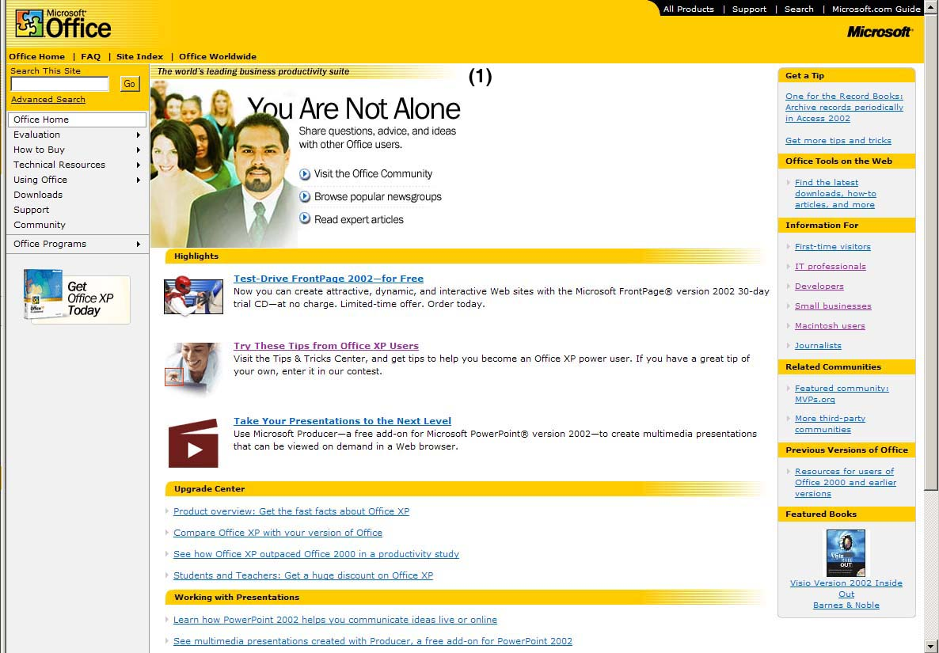
Figure 2: US Office home page (March 10, 2002)

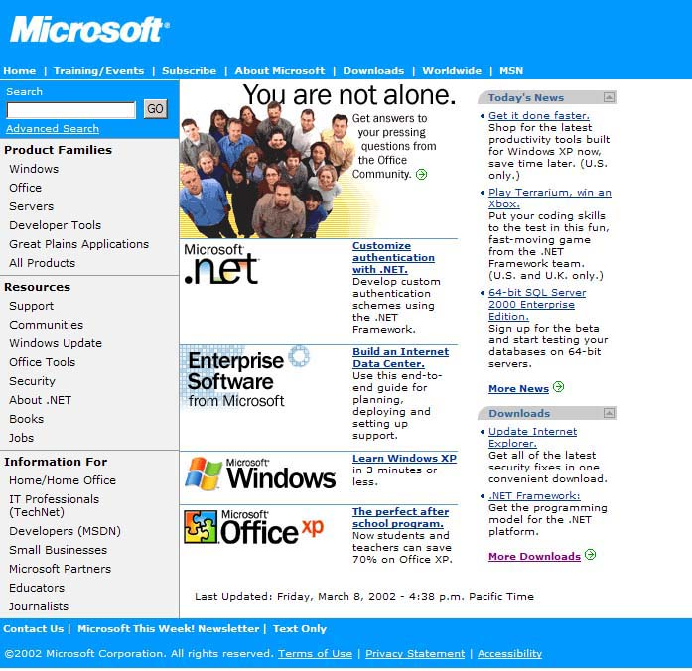
Figure 3: US Microsoft.com web site (March 10, 2002)

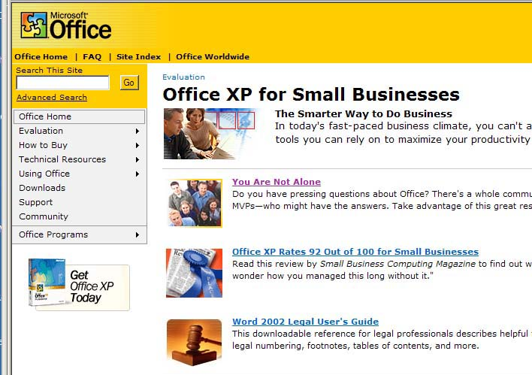
Figure 4: Office small business web site (March 10, 2002)

Sweden and Feminized Workplace Values
The Swedish Office web site presence is characterized by several significant differences from other Office web sites. The web sites often have unusual photo art and background colors. Additionally, the tone of the presentation is relaxed and friendly.

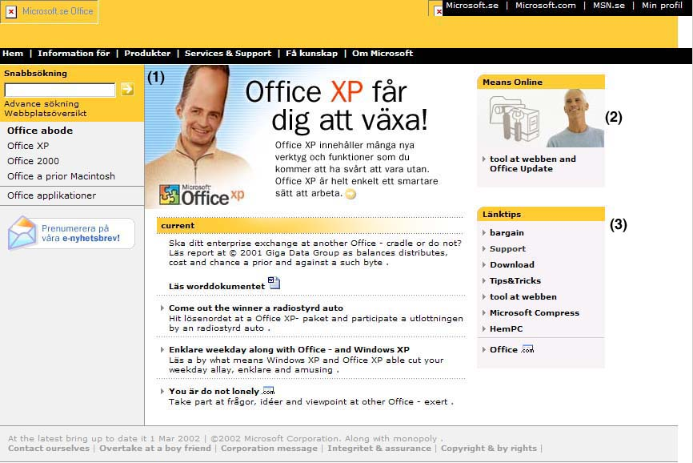
Figure 5: Office Sweden home page
The Swedish Office home page shows significant differences from the standard Microsoft template. Instead of the Microsoft library of clip art, the “filler” image is a whimsical picture of a man whose head has been expanded by the possibilities of Office XP. See note (1) on the image.
The slogan to the right of the image translates roughly as “I’m enjoying Office XP growth! Office XP has a good many functions and tools that you can’t be without. Office XP is clearly a smarter way to go.” This message partners with the humorous photo to convey a relaxed sense of personal achievement.
Item (2) is a secondary image (of a man smiling) that does not appear in any other international sites. This section is a link to development tools and Office Update features. Again, the individual is smiling widely and appears relaxed and happy.
Item (3) is a navigation pane containing links normally nested in the left-hand navigation bar. The “breaking out” of these links, and their association with image (2), continues the flow and association with relaxation.

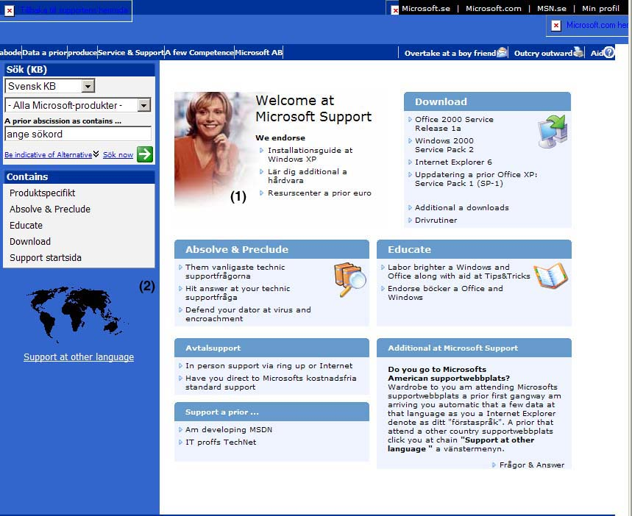
Figure 6: Sweden Office support
Once again, the Swedish Office Support page is significantly different from other Office sites. For the most part, the Microsoft template is not followed.
The Swedish Support page is the only site found that has bright background colors, a photo of a human being, and support sub-categorizations by types of help rather than Office product groups. The support pages of other Office sites are either links to the US site, or text-oriented Office product categories. Often, other Support sites have a prominent section explaining what type of help is available to the visitor based on cost (see figure 7 below).
Note (1) refers to the photograph in the “filler” section. The smiling, friendly female support person is the only human being pictured in international and US support pages. This photo may not be part of the standard Microsoft photo library, since it does not appear in any other sites researched.
Note (2) refers to the “support at other languages” section link. Once again, this is also unusual, and only occurs within a few Nordic sites.
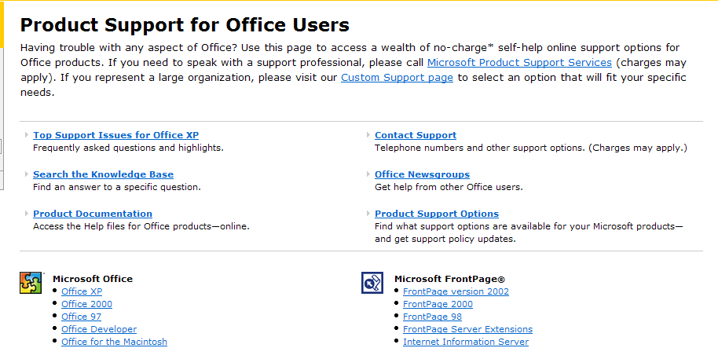
Figure 7: Typical example of an Office Support page from the US Office web site

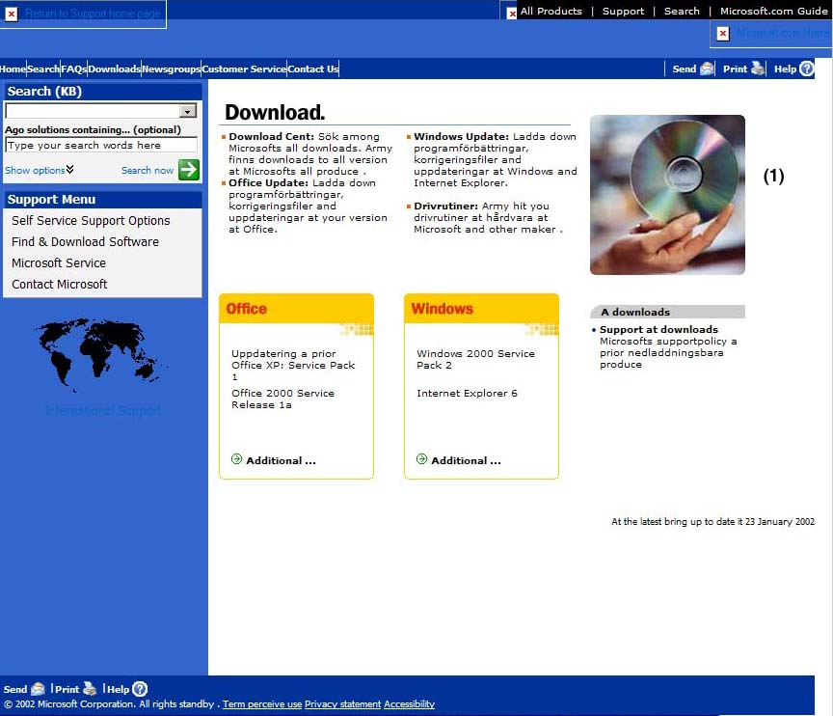
Figure 8: Swedish Office Download site
The Swedish Office Download site exhibits the same characteristics as the Support page, with its colored background and photograph. This is the only Download site that includes a photograph, which is the hand of a human being (see Note 1).
We can make several observations here regarding the obvious “relaxed, pleasant, non-competitive” feeling of the Swedish Office web site. The observations fit clearly within Hofstede’s description of a feminine workplace culture. The web site emphasizes goals such as a friendly atmosphere, a high comfort level, and accessibility to help when needed.

The Cartoon Culture of Japan

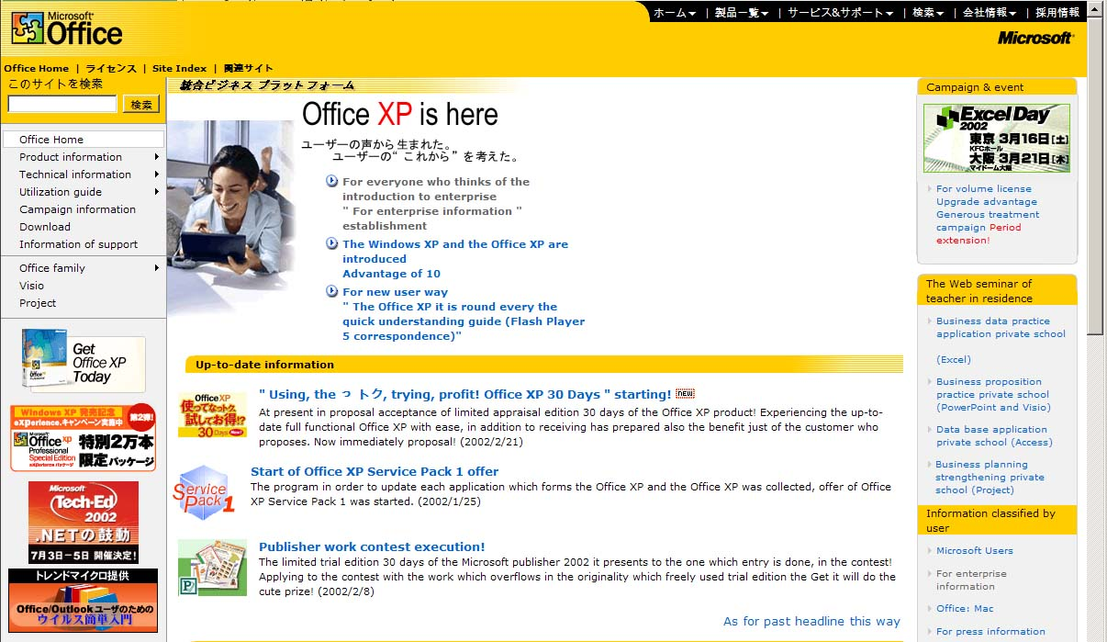
Figure 9: Japan Office home page
The opening image in the Japanese office home page depicts a relaxed, happy young woman working on her laptop computer at home. The photo appears to be a Caucasian woman in her mid-20s in bare feet, next to a window box on a couch. It is probable that this image is of an American young woman relaxing in her home. The bare feet and supine position indicates her relaxation. Although the scene is very American (Japanese homes tend not to have such large windows with unobstructed views), the fact she is barefoot is culturally relevant to the Japanese norm of removing shoes at the entrance to a residence.
In using this image, the designers are able to ascribe some relevance to the graphics, without entering into situations that would display typical Japanese work environments. Thus, we avoid any references to the Hofstede cultural identifiers of Power Distances, Masculine work goals, or Long Term Orientation. The two Hofstede identifiers that might apply are Individualism and Uncertainty Avoidance. The young woman in this photo is alone and happily engaging technology. There is nothing to indicate that her uncertainty avoidance is high, and she is depicted quite clearly as an individual. Hofstede’s cultural identifiers get a grade of D-.
Trompenaars’ cultural identifiers rate Japanese cultures as being particularist, collectivist, abscribist, and time-synchronist. Again, many of these identifiers cannot be used because of the lack of a professional or community setting. Trompenaars’ identifiers also have a low relevance to this localized product.

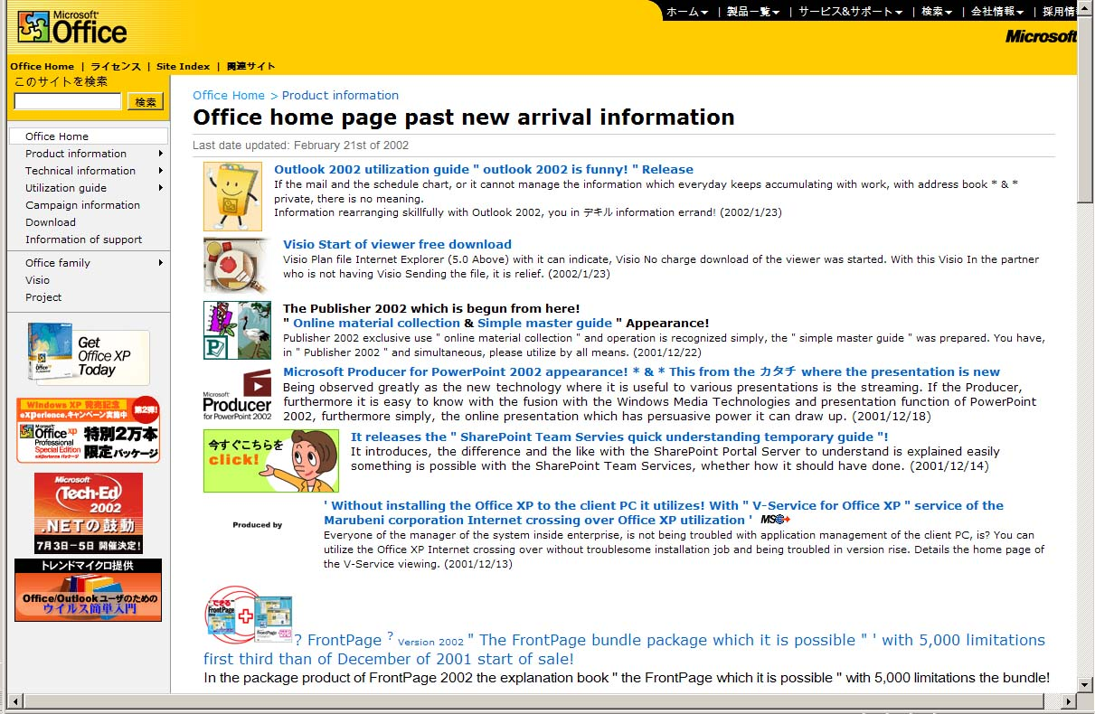
Figure 10: Japan Office web site (second level)

Japanese Popular Culture of Cartoons
The web site in figure 7 above is a second-level link from the Office home page. In it, we see the typical cartoon images prevalent in Japanese popular culture. This page has a great deal of real estate devoted to colorful cartoons and advertisements, and the page keeps an amusing tone. The first link informs us, “Office 2002 utilization guide – Outlook 2002 is funny!” In several cases, a cartoon image replaces the role of the standard Microsoft clip part library.
These two web sites reiterate that the localization used here did not conform to the assumed “cultural identifiers” assigned by Hofstede and Trompenaars. The localization is instead based on Japanese popular culture, which has little similarity to the Japanese culture of Hofstede and Trompenaars.

Discussion
Perhaps the most remarkable result of this research is the lack of internationalization performed on the Office web sites. The use of common Microsoft stock photography and icons did not allow web site localizers much latitude, although it is evident that each localizer had a preferred image of an Office “consumer/user” gracing the Office home page.
But in many cases, the web sites were not even generally localized into the native languages. The reason for this remains unclear. Is it assumed that the local software-buying population is fluent in English, and needs no translation? Does Microsoft assume that all Office consumer/users are essentially the same, and want to do the same things with their Office software?
This is the danger of assuming cultural similarities that Venkatesh warns about in his paper. The example of the moped reminds us that, despite our surface similarities, we often use the same things differently depending on our socio-economic and geographical positioning.
It is very appealing to apply positivist frameworks in analyzing cultural differences. In constructing their frameworks, Hofstede and Trompenaars both attempt to categorize and quantify cultural characteristics. One of the goals of such frameworks is to provide the researcher with a metric with which to use in cross-cultural studies. Another goal is to create a relevant vernacular. And Marcus and Gould argue convincingly for continuing to use the Hofstede cultural identifiers in addition to new tools.
I believe that technical communication artifacts, rather than being based in cultural identifiers, are instead based on the artifacts of popular culture, which are a secondary expression of culture and are also easily analyzed.
Japan provides a good example, and supports my theory. The Japanese are considered reserved and conservative and, in fact, they do interact mostly within these traditional confines. However, Japanese technical communications (including manuals) often includes manga-style cartoons to convey information. Thus, Japanese popular culture informs the technical writing culture.
I suggest a review of successfully localized technical documents to learn if their cultural identifiers are based on popular culture, rather than the traditional structures of their culture. This research could prove very fruitful.
First, the examiner would need to gain an understanding of a nation’s popular culture by examining key components of the culture, such as the role of television, radio, consumer habits, newspapers and magazines. (This would be similar to Venkatesh’s idea of “immersion.”) They could then discriminate data into groups to create a “popular culture schema.” Finally, the popular culture schema would then be
In reviewing what a culture really reads and enjoys, as opposed to cultural studies that try to analyze what a culture consists of, a more thorough and appropriate approach to localization could be performed.

References
Campbell, Charles. “Beyond Language: Cultural Predispositions in Business Correspondence.” Paper presented at Region 5 STC Conference, Fort Worth, Texas, 20 February 1998.
Hofstede, G. Cultures and Organizations: Software of the Mind: Intercultural Cooperation and its Importance for Survival, McGraw Hill, New York, 1997.
---. Culture's Consequences: International Differences in Work-Related Values. Sage, Beverly Hills, California, 1980.
Hoft, Nancy. “Approaches to International Communication.” International Technical Communication. New York: John Wiley 1995, 11-30.
Marcus, Aaron and Emilie Gould. “Cultural Dimensions and Global Web User-Interface Design: What? So What? Now What?” Proceedings of the 6th Conference on Human Factors and the Web, Austin, Texas, 19 June 2000.
Nielsen, Jakob and Marie Tahir. Homepage Usability: 50 Websites Deconstructed. New Riders Publishing, 2002.
Venkatesh, Alladi. “Ethnoconsumerism: A New Paradigm to Study Cultural and Cross-Cultural Consumer Behavior.” Marketing in a Multicultural World. J.A. Costa and G. Bamossy (eds). Beverly Hills, California: SAGE Publications 1995, 26.27.
Appendix 1: Hofstede cultural identifiers index
PDI: Power distance index
IDV: Individualism index
MAS: Masculinity index
UAI: Uncertainty avoidance index
LTO: Long-term orientation index
 | PDI |  | IDV |  | MAS |  | UAI |  | LTO
 | rank | score | rank | score | rank | score | rank | score | rank | score
Arab Countries | 7 | 80 | 26/27 | 38 | 23 | 53 | 27 | 68
Argentina | 35/36 | 49 | 22/23 | 46 | 20/21 | 56 | 10/15 | 86
Australia | 41 | 36 | 2 | 90 | 16 | 61 | 37 | 51 | 15 | 31
Austria | 53 | 11 | 18 | 55 | 2 | 79 | 24/25 | 70
Bangladesh |  |  |  |  |  |  |  |  | 11 | 40
Belgium | 20 | 65 | 8 | 75 | 22 | 54 | 5/6 | 94
Brazil | 14 | 69 | 26/27 | 38 | 27 | 49 | 21/22 | 76 | 6 | 65
Canada | 39 | 39 | 4/5 | 80 | 24 | 52 | 41/42 | 48 | 20 | 23
Chile | 24/25 | 63 | 38 | 23 | 46 | 28 | 10/15 | 86
China |  |  |  |  |  |  |  |  | 1 | 118
Columbia | 17 | 67 | 49 | 13 | 11/12 | 64 | 20 | 80
Costa Rica | 42/44 | 35 | 46 | 15 | 48/49 | 21 | 10/15 | 86
Denmark | 51 | 18 | 9 | 74 | 50 | 16 | 51 | 23
East Africa | 21/23 | 64 | 33/35 | 27 | 39 | 41 | 36 | 52
Ecuador | 8/9 | 78 | 52 | 8 | 13/14 | 63 | 28 | 67
Finland | 46 | 33 | 17 | 63 | 47 | 26 | 31/32 | 59
France | 15/16 | 68 | 10/11 | 71 | 35/36 | 43 | 10/15 | 86
Germany FR | 42/44 | 35 | 15 | 67 | 9/10 | 66 | 29 | 65 | 14 | 31
Great Britain | 42/44 | 35 | 3 | 89 | 9/10 | 66 | 47/48 | 35 | 18 | 25
Greece | 27/28 | 60 | 30 | 35 | 18/19 | 57 | 1 | 112
Guatemala | 2/3 | 95 | 53 | 6 | 43 | 37 | 3 | 101
Hong Kong | 15/16 | 68 | 37 | 25 | 18/19 | 57 | 49/50 | 29 | 2 | 96
India | 10/11 | 77 | 21 | 48 | 20/21 | 56 | 45 | 40 | 7 | 61
Indonesia | 8/9 | 78 | 47/48 | 14 | 30/31 | 46 | 41/42 | 48
Iran | 29/30 | 58 | 24 | 41 | 35/36 | 43 | 31/32 | 59
Ireland (Rep of) | 49 | 28 | 12 | 70 | 7/8 | 68 | 47/48 | 35
Israel | 52 | 13 | 19 | 54 | 29 | 47 | 19 | 81
Italy | 34 | 50 | 7 | 76 | 4/5 | 70 | 23 | 75
Jamaica | 37 | 45 | 25 | 39 | 7/8 | 68 | 52 | 13
Japan | 33 | 54 | 22/23 | 46 | 1 | 95 | 7 | 92 | 4 | 80
Malaysia | 1 | 104 | 36 | 26 | 25/26 | 50 | 46 | 36
Mexico | 5/6 | 81 | 32 | 30 | 6 | 69 | 18 | 82
Netherlands | 40 | 38 | 4/5 | 80 | 51 | 14 | 35 | 53 | 10 | 44
New Zealand | 50 | 22 | 6 | 79 | 17 | 58 | 39/40 | 49 | 16 | 30
Nigeria |  |  |  |  |  |  |  |  | 22 | 16
Norway | 47/48 | 31 | 13 | 69 | 52 | 8 | 38 | 50
Pakistan | 32 | 55 | 47/48 | 14 | 25/26 | 50 | 24/25 | 70 | 23 | 0
Panama | 2/3 | 95 | 51 | 11 | 34 | 44 | 10/15 | 86
Peru | 21/23 | 64 | 45 | 16 | 37/38 | 42 | 9 | 87
Philippines | 4 | 94 | 31 | 32 | 11/12 | 64 | 44 | 44 | 21 | 19
Poland |  |  |  |  |  |  |  |  | 13 | 32
Portugal | 24/25 | 63 | 33/35 | 27 | 45 | 31 | 2 | 104
Salvador | 18/19 | 66 | 42 | 19 | 40 | 40 | 5/6 | 94
Singapore | 13 | 74 | 39/41 | 20 | 28 | 48 | 53 | 8 | 9 | 48
South Africa | 35/36 | 49 | 16 | 65 | 13/14 | 63 | 39/40 | 49
South Korea | 27/28 | 60 | 43 | 18 | 41 | 39 | 16/17 | 85 | 5 | 75
Spain | 31 | 57 | 20 | 51 | 37/38 | 42 | 10/15 | 86
Sweden | 47/48 | 31 | 10/11 | 71 | 53 | 5 | 49/50 | 29 | 12 | 33
Switzerland | 45 | 34 | 14 | 68 | 4/5 | 70 | 33 | 58
Taiwan | 29/30 | 58 | 44 | 17 | 32/33 | 45 | 26 | 69 | 3 | 87
Thailand | 21/23 | 64 | 39/41 | 20 | 44 | 34 | 30 | 64 | 8 | 56
Turkey | 18/19 | 66 | 28 | 37 | 32/3 | 45 | 16/17 | 85
Uruguay | 26 | 61 | 29 | 36 | 42 | 38 | 4 | 100
USA | 38 | 40 | 1 | 91 | 15 | 62 | 43 | 46 | 17 | 29
Venezuela | 5/6 | 81 | 50 | 12 | 3 | 73 | 21/22 | 76
West Africa | 10/11 | 77 | 39/41 | 20 | 30/31 | 46 | 34 | 54
Yugoslavia | 12 | 76 | 33/35 | 27 | 48/49 | 21 | 8 | 88
Zimbabwe |  |  |  |  |  |  |  |  | 19 | 25

Appendix 2
Trompenaars’ Seven Cultural Identifiers (1993)

Country: | UNIV  (high)  vs.  PART  (low)  SCORE | SPEC  (high)  vs.  DIFF  (low)  SCORE | INDV  (high)  vs.  COMM  (low)  SCORE | ENV CONT  (high)  vs.  NO ENV CONT  (low)  SCORE | ACHV  (high)  vs.  ASCR  (low)  SCORE | EQUAL  (high)  vs.  HIER  (low)  RANK | SEQ TIME  (high)  vs.  SYNC TIME  (low)  RANK
Japan | 61 | 19 | 43 | 41 | 42 | 12 | 11
Singapore | 60 | 25 | 44 | 42 | 44 | 11 | 5
Italy | 52 | 37 | 68 | 49 | 53 | 7 | 7
France | 48 | 26 | 73 | 60 | n/a | 10 | 9
Belgium | 62 | 47 | 77 | 48 | 59 | 8 | 8
Sweden | 90 | 42 | 80 | 45 | 61 | 4 | 2
Germany | 92 | 33 | 86 | 65 | 58 | 3 | 10
United Kingdom | 83 | 44 | 88 | 51 | 60 | 5 | 6
Netherlands | 87 | 44 | 90 | 55 | 50 | 1 | 3
Australia | 87 | 47 | 94 | 61 | 62 | 9 | 1
Canada | 86 | 52 | 94 | 64 | 62 | 6 | n/a
United States | 95 | 57 | 96 | 68 | 63 | 2 | 4

For the remainder of this paper, “artifacts” will refer to printed documents, online help systems, web sites, quick start cards, advertising brochures, and any other producible that functions as a piece of communication.
In some circumstances (discussed later), no formal localization person is assigned, and we can assume that the localization was done “in-house” at the subsidiary itself.
Hoft, p. 12.
Analysis tool from Nielsen and Tahir, 2002.
Hofstede (1980), p. 260,
Venkatesh, p. 20.
Marcus and Gold.
Campbell.

